

**Purchases and Sales Record System.**

**Team Name:** Duke' children

**Names:**

* Gutierrez Limber
* Lituma Jhonathan (Project leader)
* Loachamin Christopher
* López Andrés
* Maigua Jonathan.

**1. Introduction**

# This document is a Software Requirements Specification (SRS), for the assignment system, location of relief services, this software does not belong to any specific company.

This specification has been structured based on guidelines given by the IEEE Standard Recommended Practice for ANSI/IEEE 830 Software Requirements Specifications.

* **Problem:**

There is an entrepreneur who at the end of each month, always has account problems in his clothing store. It doesn't have a record system of purchases made by its customers, and the expenses you make also do not take account.

So, he keeps the beads on paper as he did before, but this is tedious to him, due to the excess paper that is easily lost or damaged. To understand what the program needs to do, you first need to understand a little bit about the sales and products of the store.

* **Overview:**

As we all know we are in a new era where everything needs to be digitized and in addition to being backed up.

Through this program it is intended to offer the user the best management of buying and selling and in turn facilitate the maintenance of the company's data in an orderly manner such as: inventory, sales data, returns, discounts and promotions for either seasons, special occasions and thus save time.

Our vision is to bring all this information to a database, where all this is accessible and user-friendly.

* **Background:**

To make this registration we need to know fundamental things, such as basic accounting for the organization of this data, which is described by the process related to the acquisition and payment of products or services.

Every entrepreneur should keep an orderly accounting so his business can be successful for which he must keep track of the purchases and sales he makes, also he should make a periodic elaboration of inventories, balance sheets and financial statements.

The sales record is a book in which you enter all the details of sales that the company makes. The entrepreneur should detail: date, bill number, National identity document, quantity, description, code, total VAT included.

* 1. *Purpose*

# •        The main objective is to define in a complete and concrete way the functional and non-functional requirements necessary for the development of new software for the allocation and location of relief services by validating this document.

•        The software developed belongs to the same developers, and project managers in such a way that there is no express request from an entity for the development of this software.

* 1. *Scope*

# The software product due to its main features and in relation to the administrative environment for the purpose of helping small businesses carry their business information in an orderly and up-to-date manner

It contemplates the following points in a more detailed way:

* Entrepreneur's Application

o Entry into the system

o Super User Registration

o Purchase record

* Employee Application

o Entry into the system

o Record sale

or Change password

* 1. *Personnel Involved*

|  |  |
| --- | --- |
| **Names** | **Jhonathan Lituma** |
| **Role** | **Project manager, analyst, developer, programmer** |
| **Professional category** | **A Student in Systems and Computer Science Engineering** |
| **Responsibilities** | **Code review, assistance in documentation,** |  |
| **Contact information** | [**kmmontalvo@espe.espe.edu.ec**](mailto:kmmontalvo@espe.espe.edu.ec) |  |
| **Approval** | **Yes** |  |

|  |  |
| --- | --- |
| **Name** | **Andrés Lopez** |
| **Role** | **analyst, developer, programmer, reviewer** |
| **Professional category** | **A Student in Systems and Computer Science Engineering** |
| **Responsibilities** | **Code review, help in documentation** |
| **Contact information** | **ailopez4@espe.edu.ec** |
| **Approval** | **Yes** |

|  |  |
| --- | --- |
| **Name** | **Limber Guitierrez** |
| **Role** | **analyst, developer, programmer, reviewer** |
| **Professional category** | **A Student in Systems and Computer Science Engineering** |
| **Responsibilities** | **Code review, help in documentation** |
| **Contact information** | **lsgutierrez2@espe.edu.ec** |
| **Approval** | **Yes** |

|  |  |
| --- | --- |
| **Name** | **Cristofer Loachaming** |
| **Role** | **analyst, developer, programmer, reviewer** |
| **Professional category** | **A Student in Systems and Computer Science Engineering** |
| **Responsibilities** | **Code review, help in documentation** |
| **Contact information** | **Ciloachamin@espe.edu.ec** |
| **Approval** | **Yes** |

|  |  |
| --- | --- |
| **Name** | **Jonathan Maigua** |
| **Role** | **analyst, developer, programmer, reviewer** |
| **Professional category** | **A Student in Systems and Computer Science Engineering** |
| **Responsibilities** | **Code review, help in documentation** |
| **Contact information** | **jfmaigua@espe.espe.edu.ec** |
| **Approval** | **Yes** |

*1.4. Definitions, acronyms and abbreviations*

|  |  |
| --- | --- |
| **Concept** | **Definition** |
| Administrator | Owner and/or business manager |
| User | Person in charge of registering the sale of business clothing |

*1.5. References*

|  |  |  |  |  |
| --- | --- | --- | --- | --- |
| **Reference** | **Title** | **Route** | **Date** | **Author** |
| **1** | IEEE Standard  830 | Pdf | 22/10/2008 | Ieee |
| **2** | Specifying software requirements | https://wikis.fdi.ucm.es/ | 22/10/208 | IEE Std. 830-1998 |

# *1.6. Summary*

This document consists of three sections. The first section provides an introduction to it and provides an overview of the specification of functional and non-functional requirements of the software product, its objectives, as well as scopes, as well as a description of the personnel involved in the development of the system.

The second section of the document provides an overview of the system, in order to understand the main functions that the system must perform, the associated data and the factors, constraints, assumptions, main features and dependencies that affect development, without going into excessive detail.

The third section of the document is one in which you define in detail the functional and non-functional requirements that the system must meet

**2. Overview**

*2.1. Product Outlook*

* The "Purchase and Sales record" system is a software product, which will allow access to authorized persons to the employee application by means of a user and password, using inventory display methods and sales record; by the employer's app has its record of information such as purchase record, sales record, view and add products to inventory. In a way that is ordered

# *1.1. Product functionality*

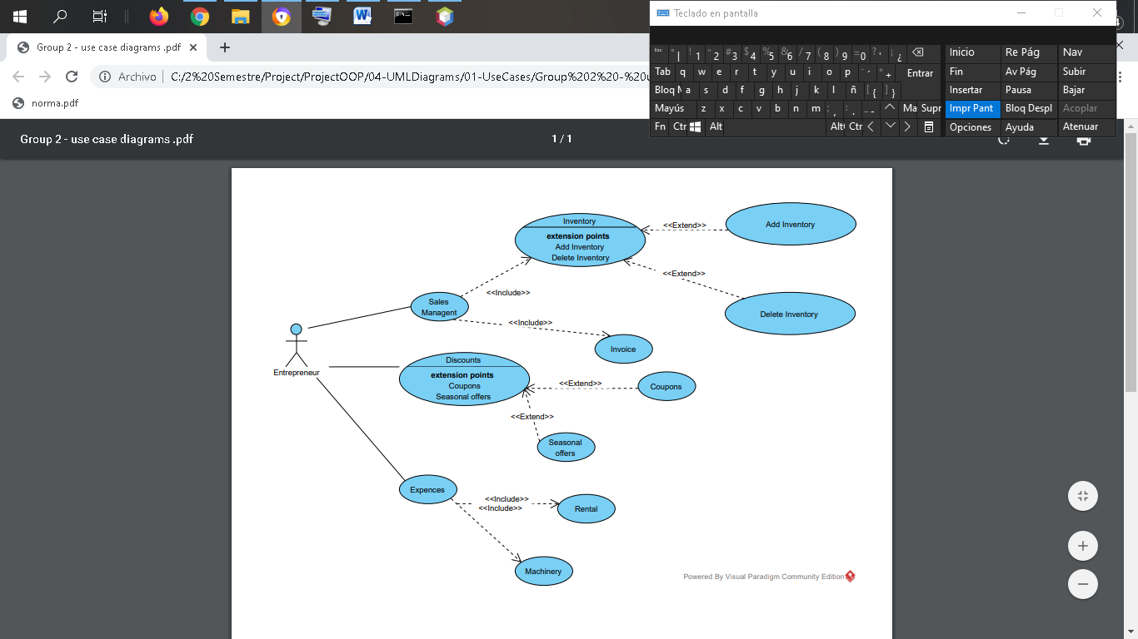

*1.2. User Characteristic*

|  |  |
| --- | --- |
| Type of user | User/Employee |
| Training | Basic Education, Baccalaureate |
| Skills | Computer handling facility |
| Activities | Register in the system, generate invoices, record sales record, manage inventory information, manage information promotions and claims |
|  |  |
| Type of user | Administrator/Entrepreneur |
| Training | Basic education, high school or higher education |
| Skills | Administrative Knowledge, experienced management in information systems (computers). |
| Activities | Manage and manage your business information such as sales and purchase records, view, add, and remove products from inventory |

*1.3. Restrictions*

# The system must be developed in Java programming language

* Information about users, purchase and sales record, inventory, promotions, must be stored in csv files.

*2.2. Assumptions and dependencies*

* The program to be delivered will only work on computers with any type of OS.
* This will have enough power (not supposed to be excessive) to be able to get results in a reasonable time.
* It is assumed that users of the software must possess knowledge and skills in the scope of their functions.
* In the event that you choose to use a database other than .csv files, the system connection must be modified.

# *2.3. Predictable evolution of the system*

It is estimated to use basic servers for application use up to 10 users, in case of concurrent users it will be able to support up to 5 users who make simultaneous accesses to the database (csv file).

**3. Specific Requirements**

*3.1. Funtional Requirements*

*User program*

**Point 1:**

**Enter the system**

* + Admission carries a record the first time and which always use
  + The record consists of a user and a key.

**Point 2: Options Menu**

* Record sale
* The sales record consists of the creation of an invoice which contains the invoice number, date, identity card, quantity, price and product description
* Purchase registration
* The purchase record will store information about the purchase of products (clothing) from the business

**Point 3: Display/Modification**

* The user or employee may view, delete aforementioned actions

*Application for the Entrepreneur*

**Point 1: Enter the system**

* The employer will be able to enter the user and the first time he will be shown the welcome to the program.
* The program will ask you for a username and password

**Point 2: Upon entering the program**

* The employer may have full access to the above functions and methods
* You will get up-to-date and detailed information about the activities that have been carried out in your business-or as users, inventory, records, claims and promotions

**Point 3: Visualization and decision-making**

* When the employer obtains all the information about his business he will be able to make the right decisions for the evolution of the business, supply/eliminate products to inventory, invoices and promotions

# *3.2. Non-functional requirements*

* The application must allow the user to interact with the application for data entry.
* The system must allow the user to register using a username and password
* The system must allow the entry of purchase and sales records, invoices to the user.
* The system must not be inconvenienced at the time of its implementation
* The system should not allow access to unregistered users.

# **4. Diagrams Class**

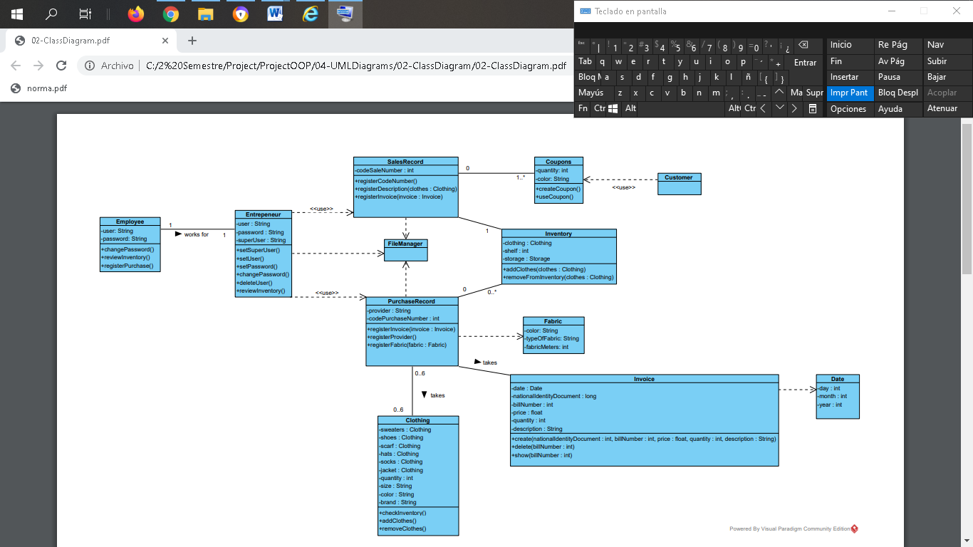

**5. Specification Use Cases**

*5.1. User Program*

***Point 1***

|  |  |
| --- | --- |
| Identifier | Point1(user/employees) |
| **Name** | Entering the system |
| **Description** | The user enters a user and password |
| **Actors** | User |
| **Preconditions** |  |
| **Postconditions** | The user is registered and the application will not ask you to register again. |

|  |
| --- |
| Normal flow of events |
| 1. Log into the system with username and password  2. Validate that there are no empty fields  3. Validate user  4. Validate password. |
| **Alternate flows and exceptions** |
| A. There are empty fields   * In step 2 if any field is empty   1. The system displays the message "Empty fields exist".  2. The system allows you to re-enter the ingress data (returns to normal flow) |
| B. Wrong user   * In step 3 if you are a user it is not valid   1. The system displays the message "user/password incorrect".  2. The system allows you to re-enter the user and password has three attempts (returns to normal flow) |
| C. Incorrect password   * In step 4 if the password   1. The system displays the message "user/password incorrect"  2. The system allows you to re-enter the user and password has three attempts (returns to normal flow) |

*Point 2*

|  |  |
| --- | --- |
| Identifier | Step 2 |
| **Name** | System Login (Options Menu) |
| **Description** | The user will choose one of the menu options |
| **Actors** | User |

|  |  |
| --- | --- |
| Preconditions | The user must be registered in the program |
| **Post-conditions** | The user has three attempts otherwise the program will be terminated |
| **Normal flow of events** | |
| 1. The user selects the menu option. | |
| **Alternate flows and exceptions** | |
|  | |

*Point 3*

|  |  |
| --- | --- |
| Identifier | Point 3 |
| **Name** | Record sale |
| **Description** | The user when he has already selected a menu option and filled will proceed to save them |
| **Actors** | User |
| **Preconditions** | User must be registered in the system. |
| **Post-conditions** | User is on the main screen of the program |
| **Normal flow of events** | |
| 1. The user fills in the data or information requested  2. The system shows you the main screen. | |
| **Alternate flows and exceptions** | |
|  | |

|  |  |
| --- | --- |
| Identifier | Point 4 |
| **Name** | Display /Modification |
| **Description** | The user can view, modify, and delete actions previously taken such as the purchase and sales record, inventory. |
| **Actors** | User |
| **Preconditions** | The user must be registered in the program |
| **Post-conditions** |  |
| **Normal flow of events** | |
| 1. The user enters the system  2. The user enters the main menu  3. The user selects one of the options displayed  4. The user add the logs by filling in the required system data  5. The system saves the changes to the corresponding records.  6. The user can view, add or delete the records  7. The user selects the option to display the inventory  8. The user may delete any invoices entered above | |
| **Alternate flows and exceptions** | |
|  | |

***5.2 Administrator/Owner Program***

|  |  |
| --- | --- |
| Identifier | Point 1 |
| **Name** | Entering the system |
| **Description** | Allows you to enter the system and display the main interface |
| **Actors** | Administrator/Owner |
| **Preconditions** | The Administrator/Owner will be welcomed to the program and may register with a username and password |
| **Postconditions** | Validate the entry of assistants into the system and remember it |
| **Normal flow of events** | |
| **1.** If this is the first time you will be welcome the system displays the login information with the user and password fields.  **2.** The Administrator/Owner enters the corresponding username and password.  **3.** Validate that there are no empty fields  **4.** If it is not the first time the program will ask for the user and password  **5.** Validate the user  **6.** Validate the password | |

|  |
| --- |
| Alternate flows and exceptions |
| A. There are empty fields   * In the event of any field, it is empty   1. The system displays the message "Empty fields exist".  2. The system allows you to re-enter the ingress data (returns to normal flow) |
| **B. Incorrect password**   * In the event that the password is incorrect   1. The system displays the message "User or password is incorrect".  2. The system allows you to re-enter the password in the login window (returns to normal flow)  3. It has three attempts, after these the program will be closed |

|  |  |
| --- | --- |
| **Identifier** | **Step 2** |
| **Name** | System Login (Options Menu) |
| **Description** | The Administrator/Owner ingrasses the system and has full control of the program will be able to choose any options from the menu |
| **Actors** | Administrator/Owner |
| **Preconditions** | Administrator/Owner must be registered in the system. |
| **Post-conditions** | Administrator/Owner is on the main screen of the program |
| **Normal flow of events** | |
| 1. The Administrator/Owner will enter the options menu  2. The Administrator/Owner may choose the register sale option  3. The Administrator/Owner may choose the register purchase option  4. The Administrator/Owner may choose the option to view inventory  5. The Administrator/Owner may add things to the inventory  6. The Administrator/Owner may remove things from inventory  7. The Administrator/Owner will be able to view invoices  8. The Administrator/Owner may delete invoices  9. Administrator/Owner may remove sales records  10. Administrator/Owner may remove purchase records | |
| **Alternate flows and exceptions** | |
|  | |

|  |  |
| --- | --- |
| Identifier | Point 3 |
| **Name** | Display /Modification |
| **Description** | The Administrator/Owner can view, modify and delete actions previously taken such as purchase and sales record, inventory. |
| **Actors** | Administrator/Owner |
| **Preconditions** | The Administrator/Owner must be registered in the program |
| **Post-conditions** |  |
| **Normal flow of events** | |
| 1. Administrator/Owner enters the system  2. Administrator/Owner enters the main menu  3. The Administrator/Owner selects one of the options displayed  4. Administrator/Owner add records by filling in required system data  5. The system saves the changes to the corresponding records.  6. Administrator/Owner may view, add or remove items from inventory  7. The Administrator/Owner selects the option to view inventory  8. The Administrator/Owner may delete any invoices previously entered  9. Administrator/Owner will have access to csv files  10. The Administrator/Owner enters access to the purchase record database  11. The Administrator/Owner will have access to the sales record database  12. The Administrator/Owner will have access to the user database  13. The Administrator/Owner is the only one who has access to the inventory  14. The Administrator/Owner will have the information of the actions taken in his  15. business in an orderly and up-to-date manner | |
| **Alternate flows and exceptions** | |
|  | |

***7. User interfaces***